**Description:**

Amazon Elastic Compute Cloud (Amazon EC2) provides scalable computing capacity in the Amazon Web Services (AWS) cloud. Using Amazon EC2 eliminates your need to invest in hardware up front so you can develop and deploy applications faster. You can use Amazon EC2 to launch as many or as few virtual servers as you need, configure security and networking, and manage storage. Amazon EC2 enables you to scale up or down to handle changes in requirements or spikes in popularity, reducing your need to forecast traffic.

**Problem Statement:**

Company ABC wants to move their product to AWS. They have the following things set up right now:

1. MySQL DB

2. Website (PHP)

The company wants high availability on this product, therefore wants Auto Scaling to be enabled on this website.

**Steps To Solve:**

1. Launch an EC2 Instance

2. Enable Auto Scaling on these instances (minimum 2)

3. Create an RDS Instance

4. Create Database & Table in RDS instance:

a. Database name: intel

b. Table name: data

c. Database password: intel123

5. Change hostname in website

6. Allow traffic from EC2 to RDS instance

7. Allow all-traffic to EC2 instance

**Create a EC2 instance “Pradip-project”**

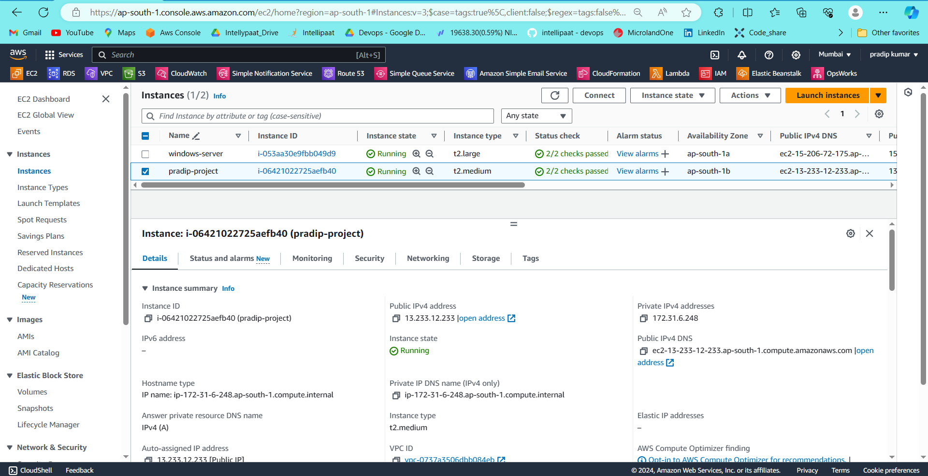

**Now connect the instance and install web service**

**Sudo apt install apache2 -y**

**And make index.php file at place of index.html file**

**Now I have launched website**

**For save this data in mysql database**

**Now I have created a database**

**Now give endpoint,username,password and database name**

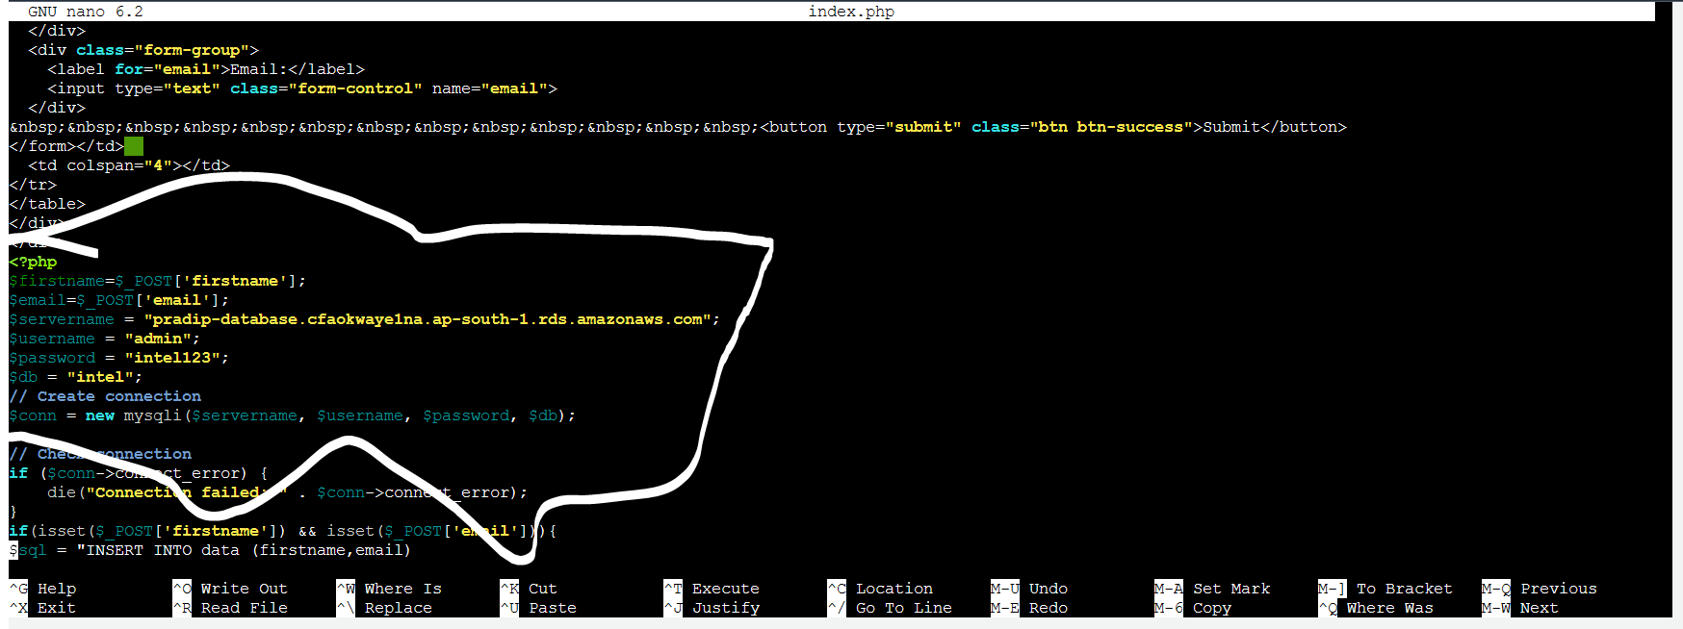

**After that create a table data**

**Create table data (firstname varchar(), email varchar(25));**

**Now connection has been successfully ec2 with mysql db**

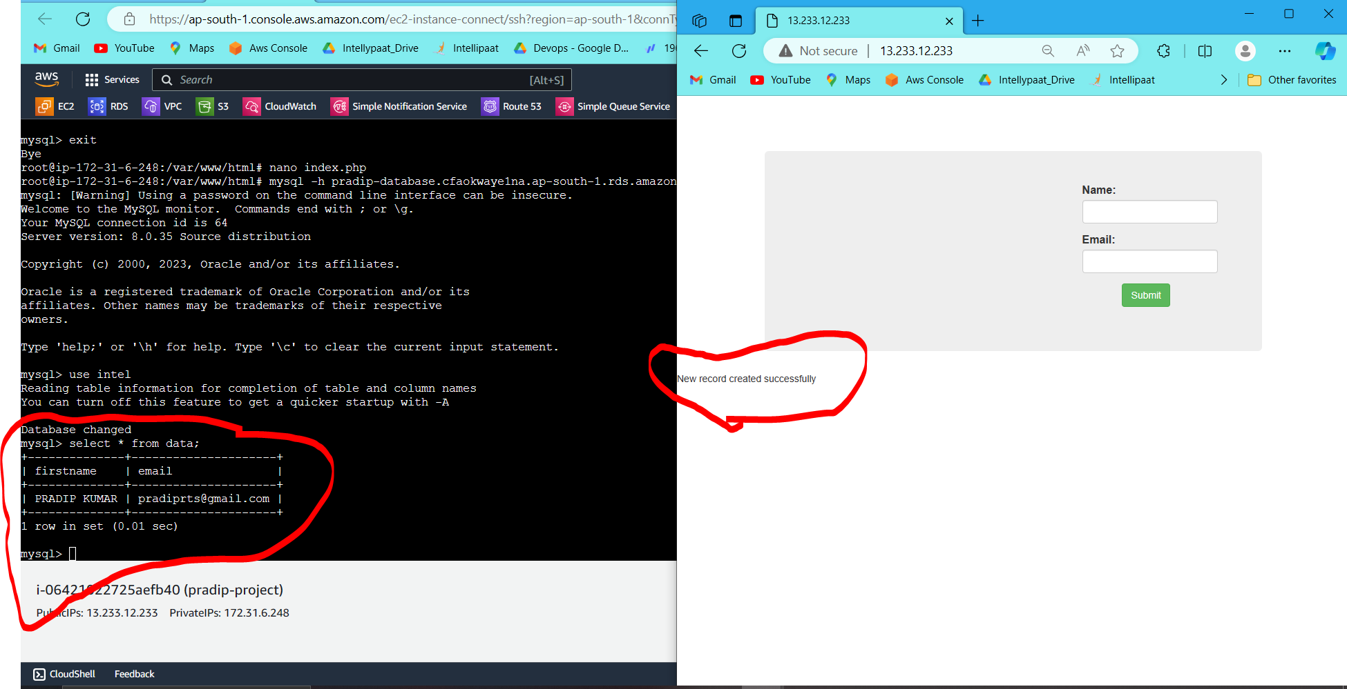

**Create template from this instance**

**Create autoscaling with this template**

**Now autoscaling has been created**

**You can check after creating of autoscaling group 2 instances automatic created**

**As per load increasing instance will be create**

**Thanks**